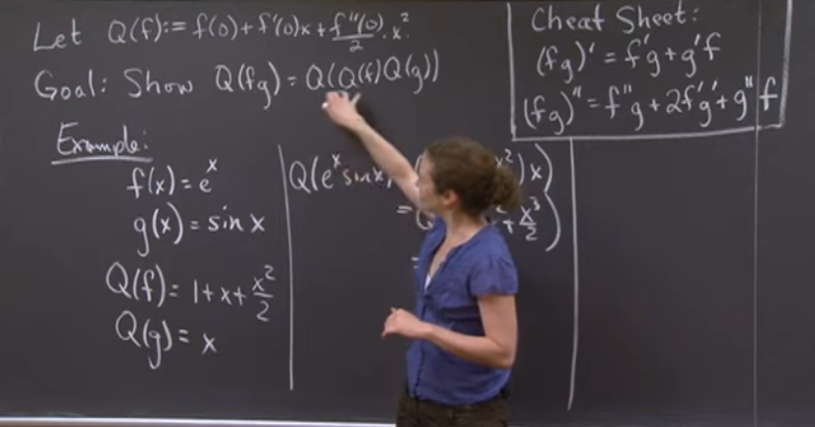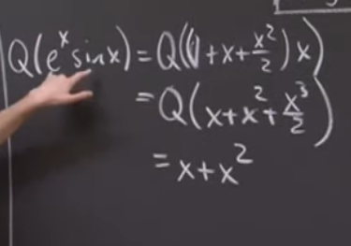

RIGHT HAND SIDE

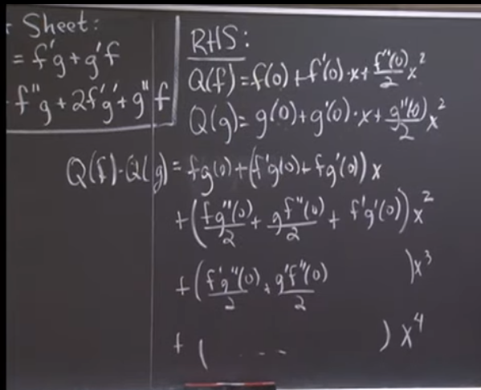

Applying Quadratic Approximation, the following terms stays:

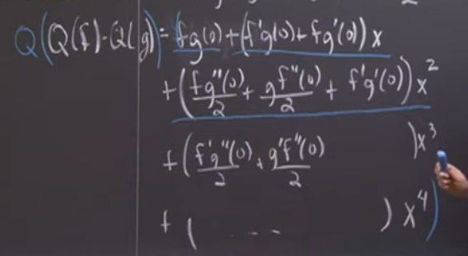

* Constant, linear, and quadratic only

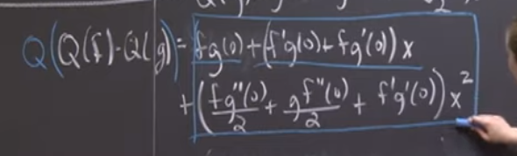

LEFT HAND SIDE

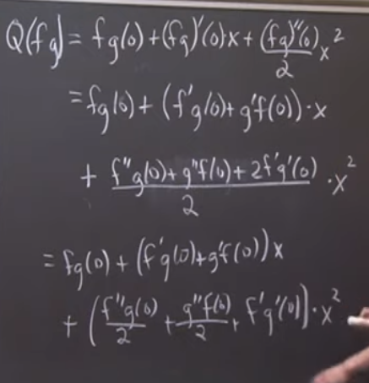

WORKED EXAMPLE

Using the direct method

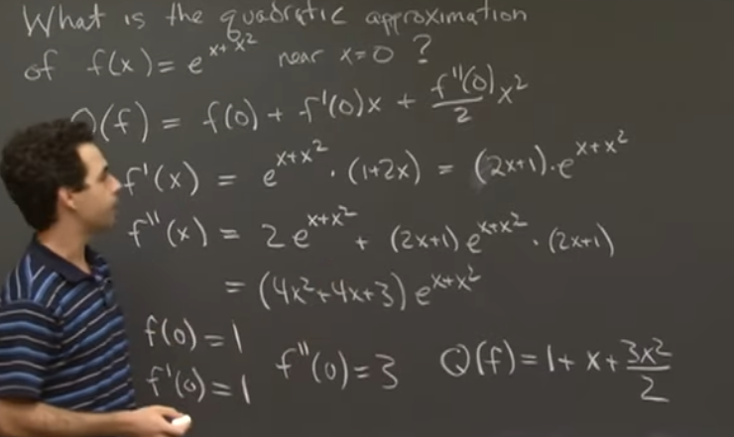

Using the product method

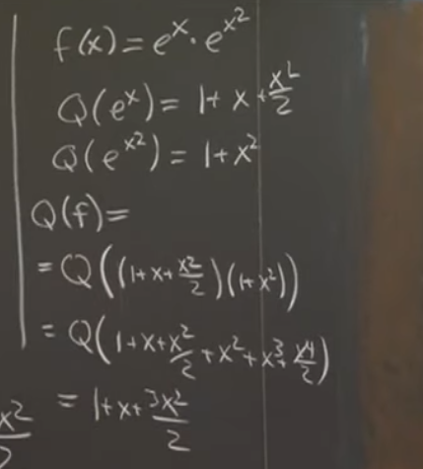

* For polynomials, drop only the higher order functions (higher than the quadratic)